**FINAL PROJECT**

**ASD – CS525**

**PART A**

The framework with all classes that are annotated with @Service and apply dependency injection to all fields that are annotated with @Autowired.

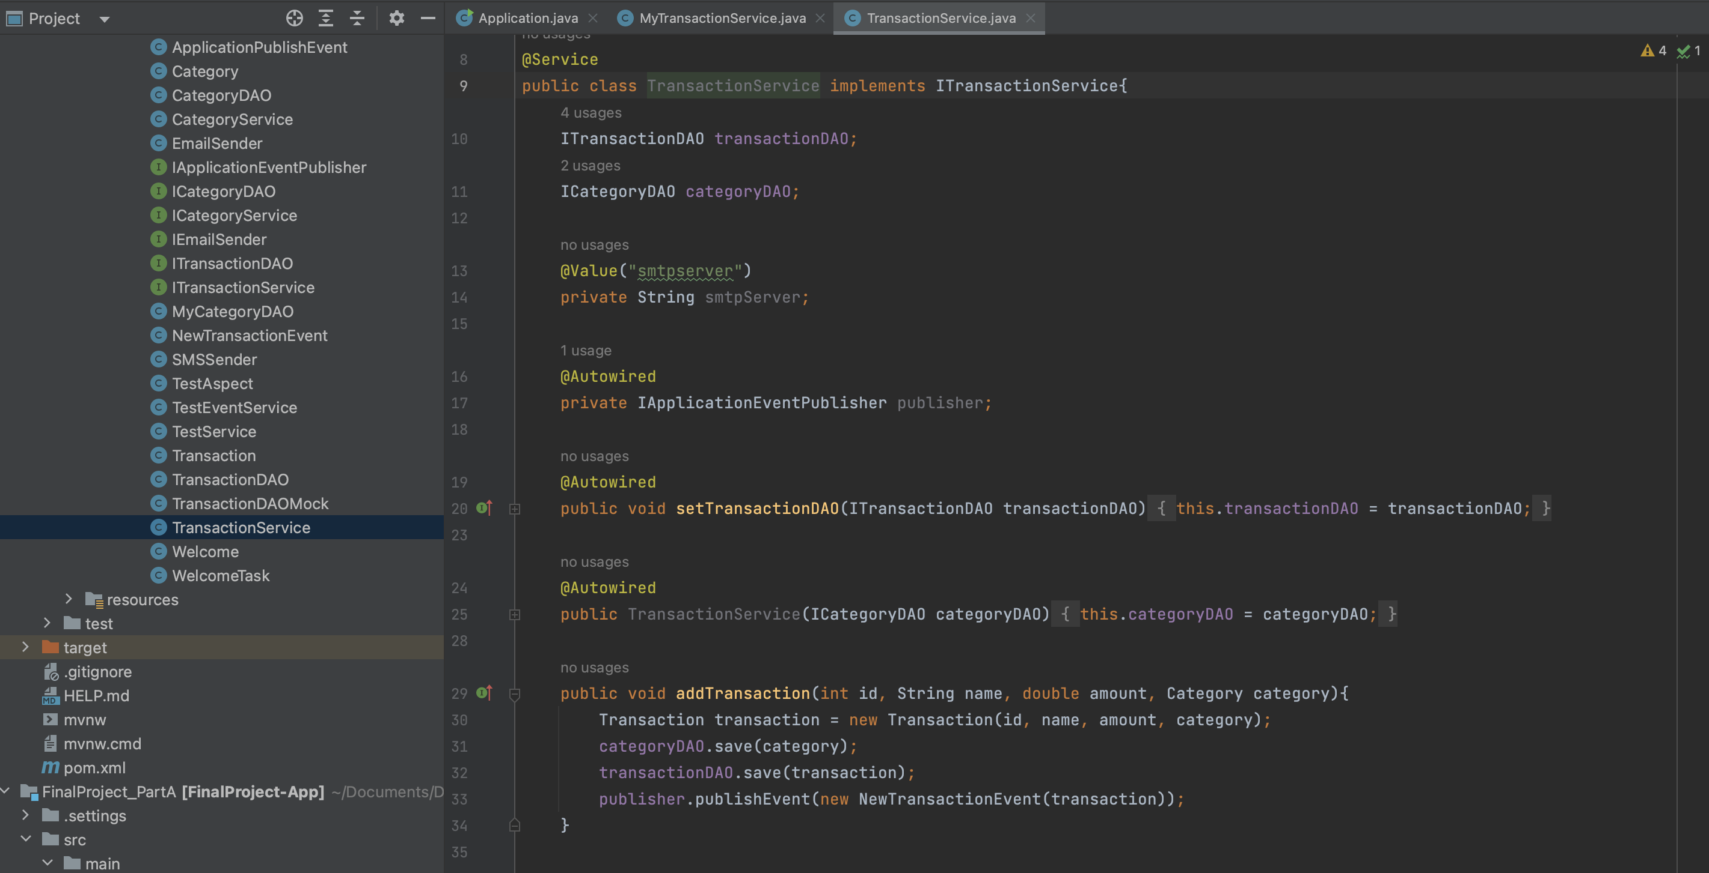

The application uses the framework successfully.

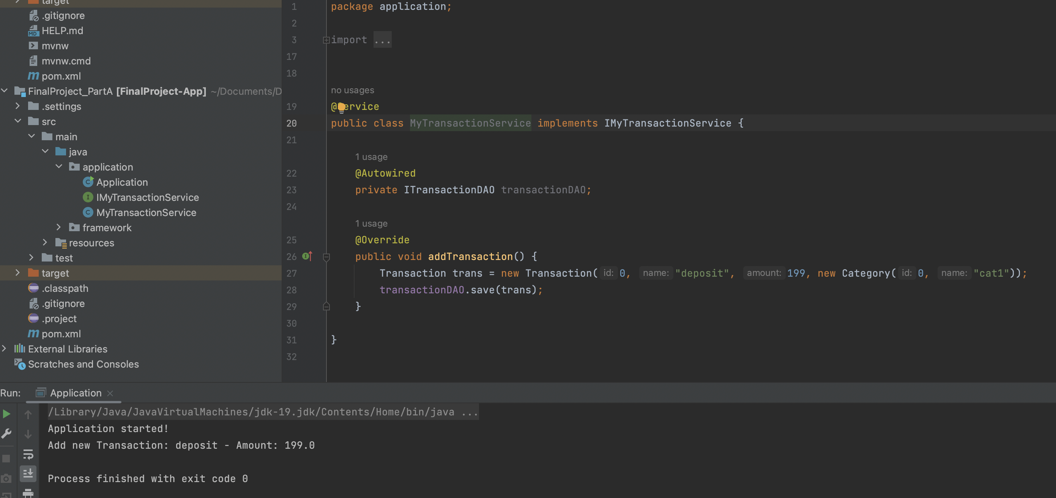

**PART B**

Framework supports field injection by name using the @Qualifier annotation

The application uses the framework successfully.

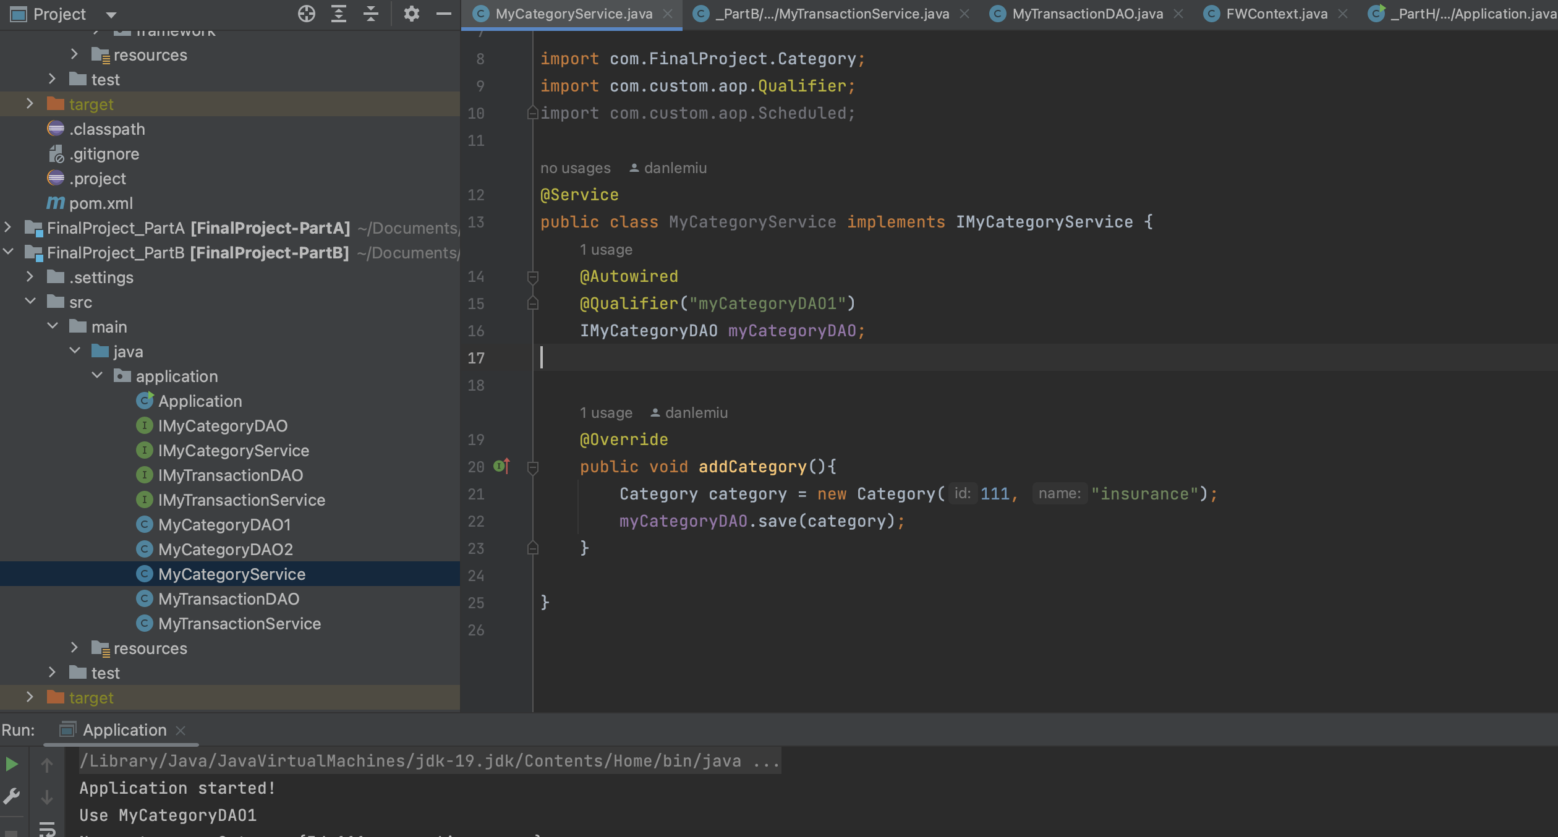

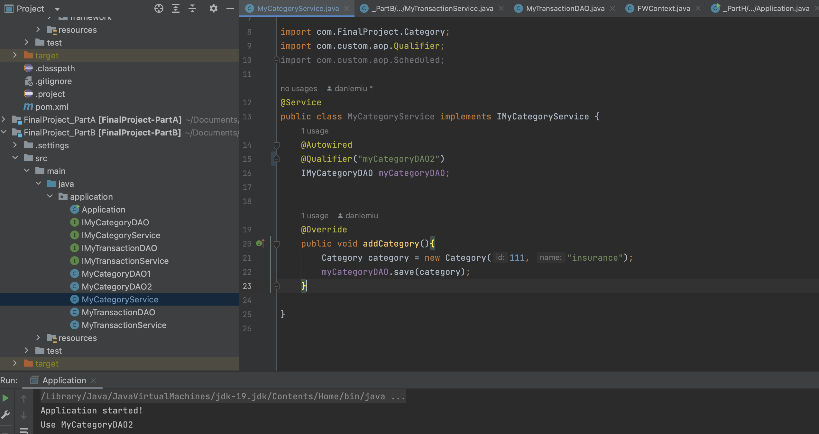

Framework supports:

* Setter injection by placing the @Autowired on the setter method
* Constructor injection by placing the @Autowired on the constructor

The application uses the framework successfully.

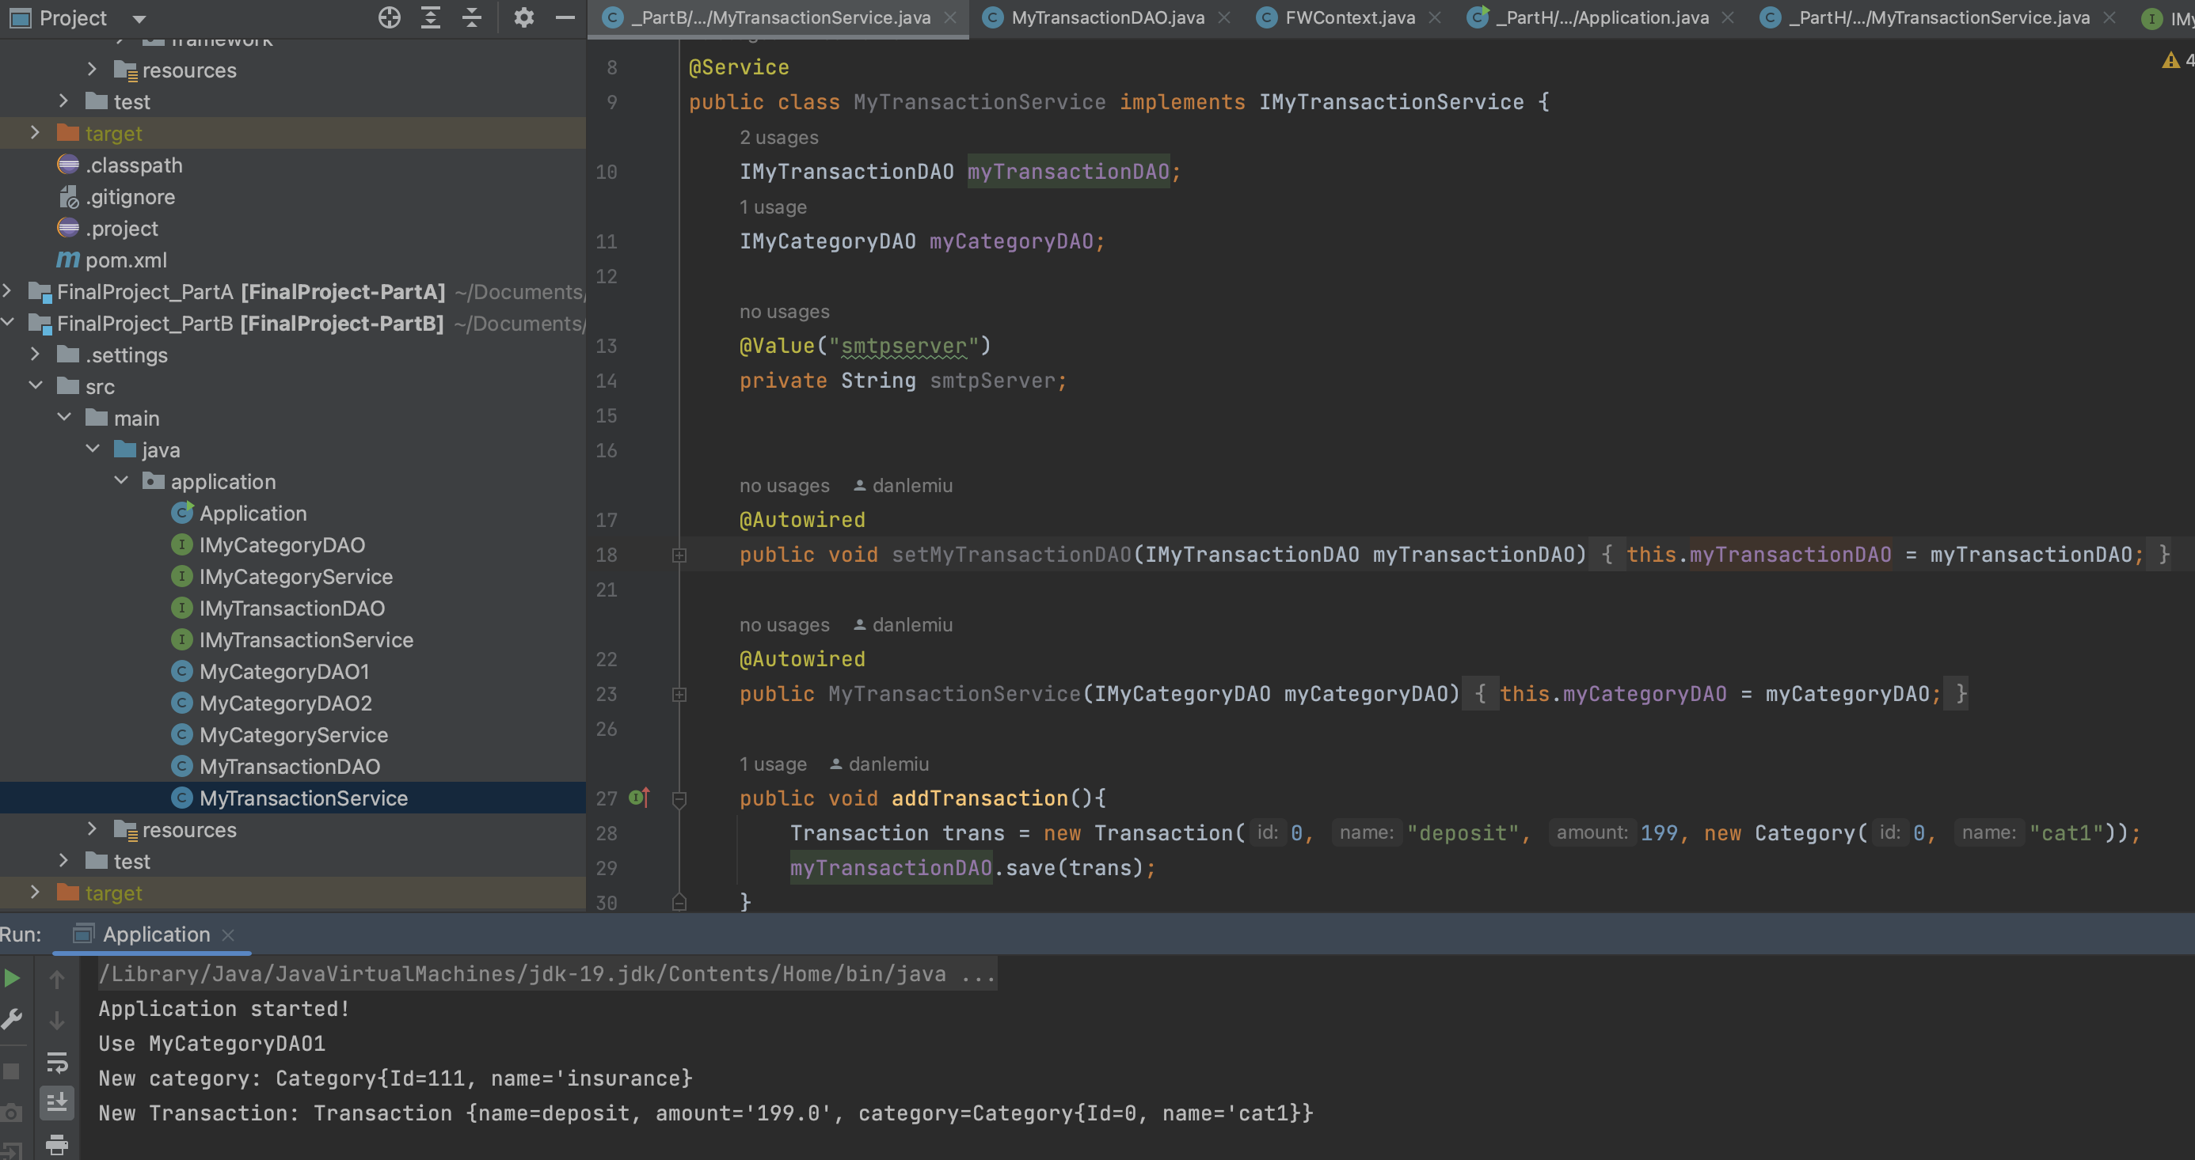

**PART C**

Inject value for smtpServer in EmailSender

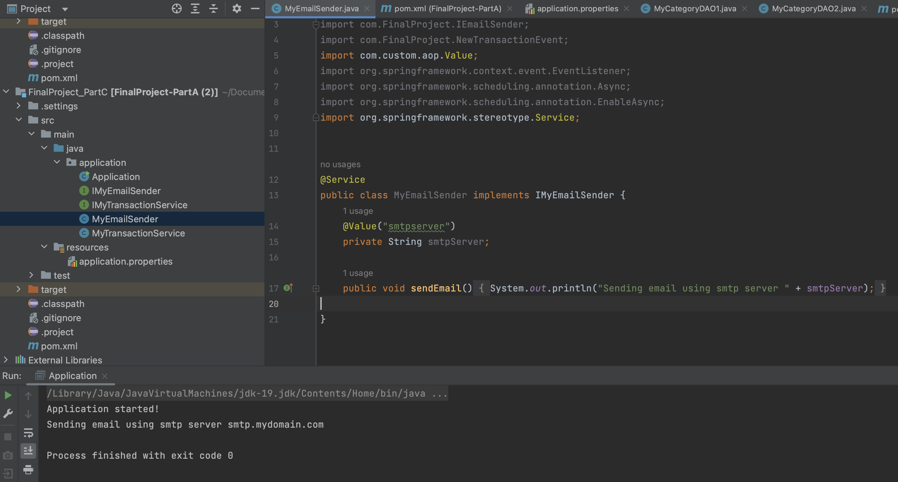

In application.properties, set smtpserver = smtp.mydomain.com

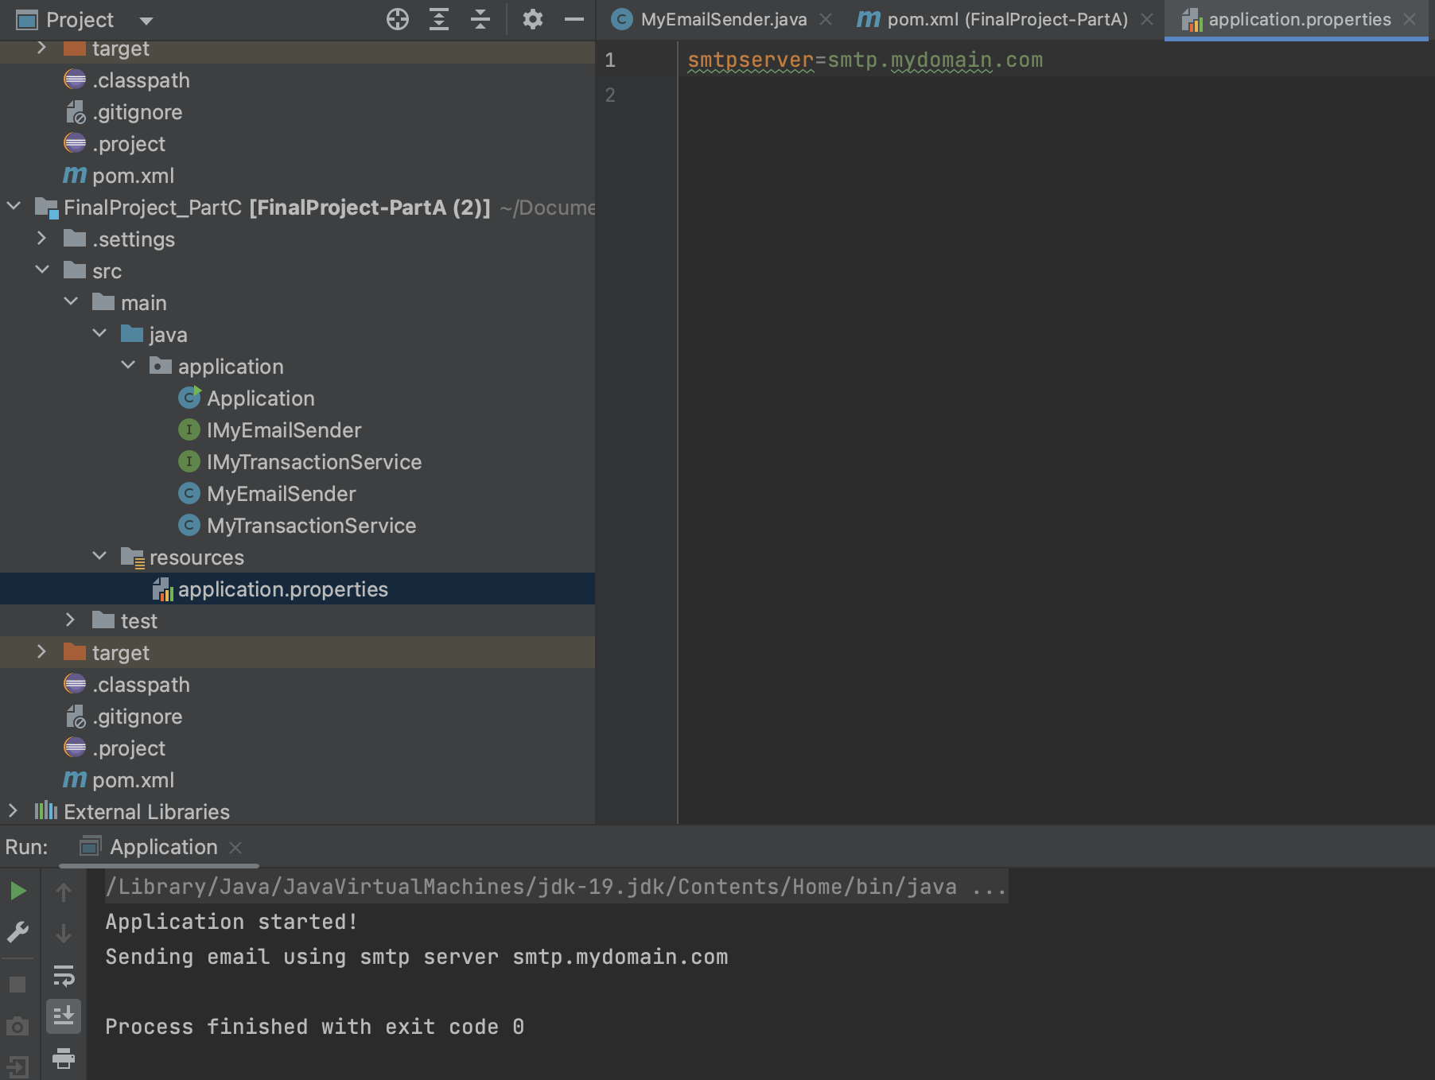

**PART D**

Modified the framework so that the Application class with the main method looks similar as the Application class in Spring Boot.

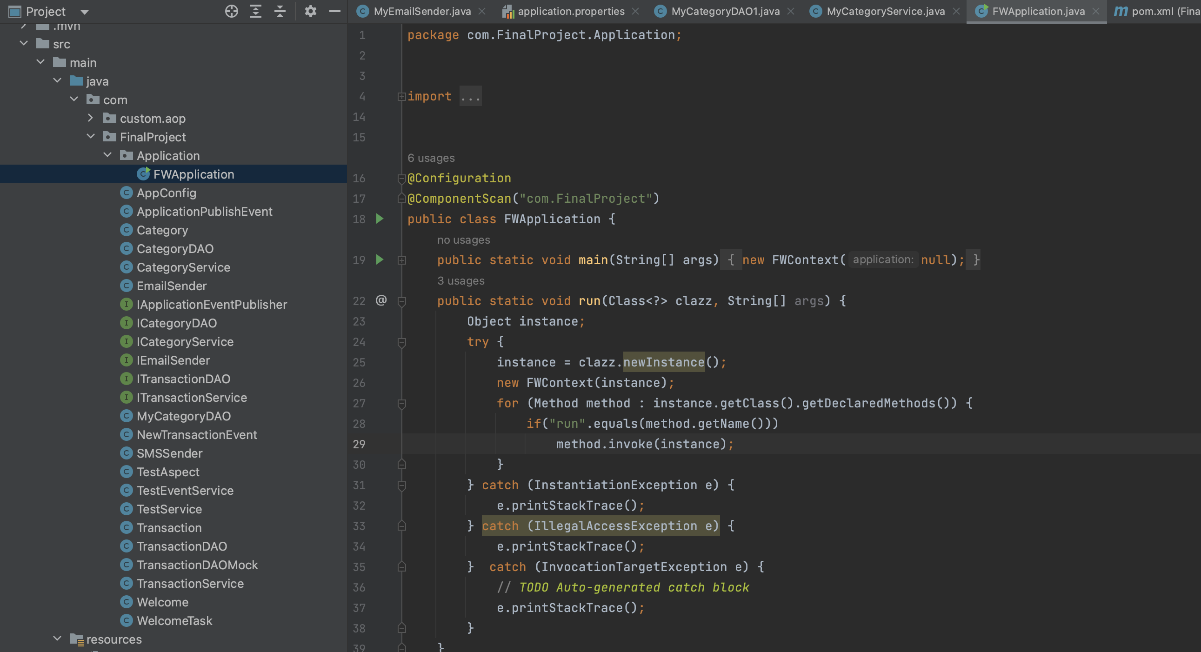

The application has the framework jar as dependency.

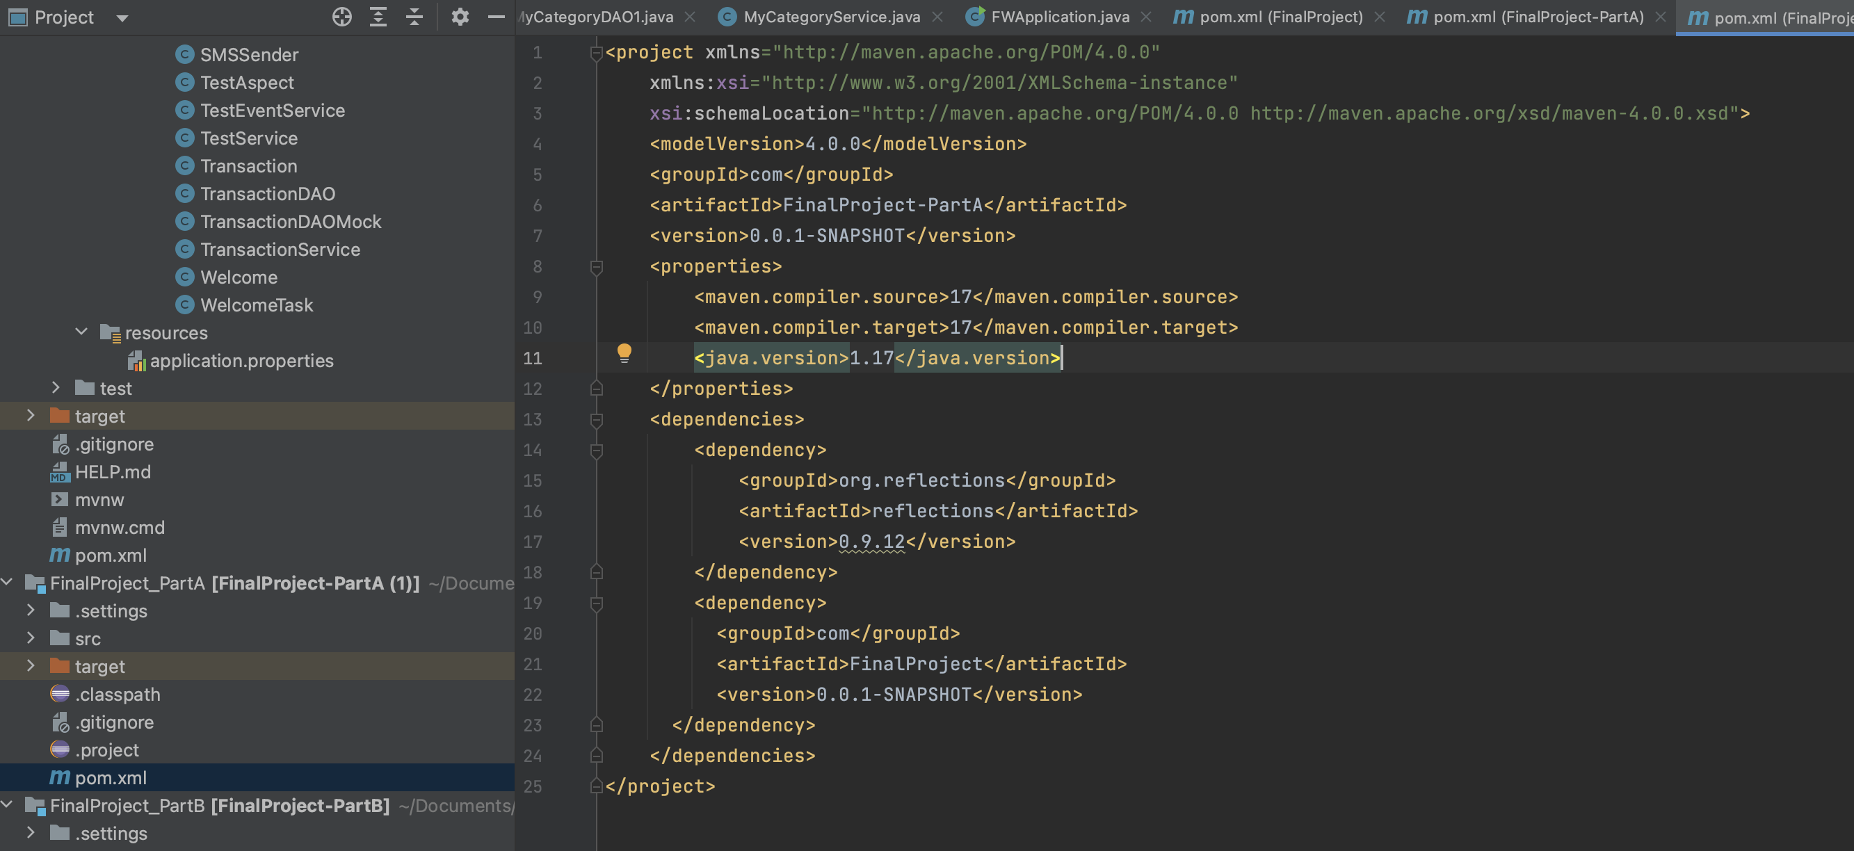

The application uses the framework successfully.



**PART E**

The framework supports profile like in Spring Boot.

The application uses the framework successfully.

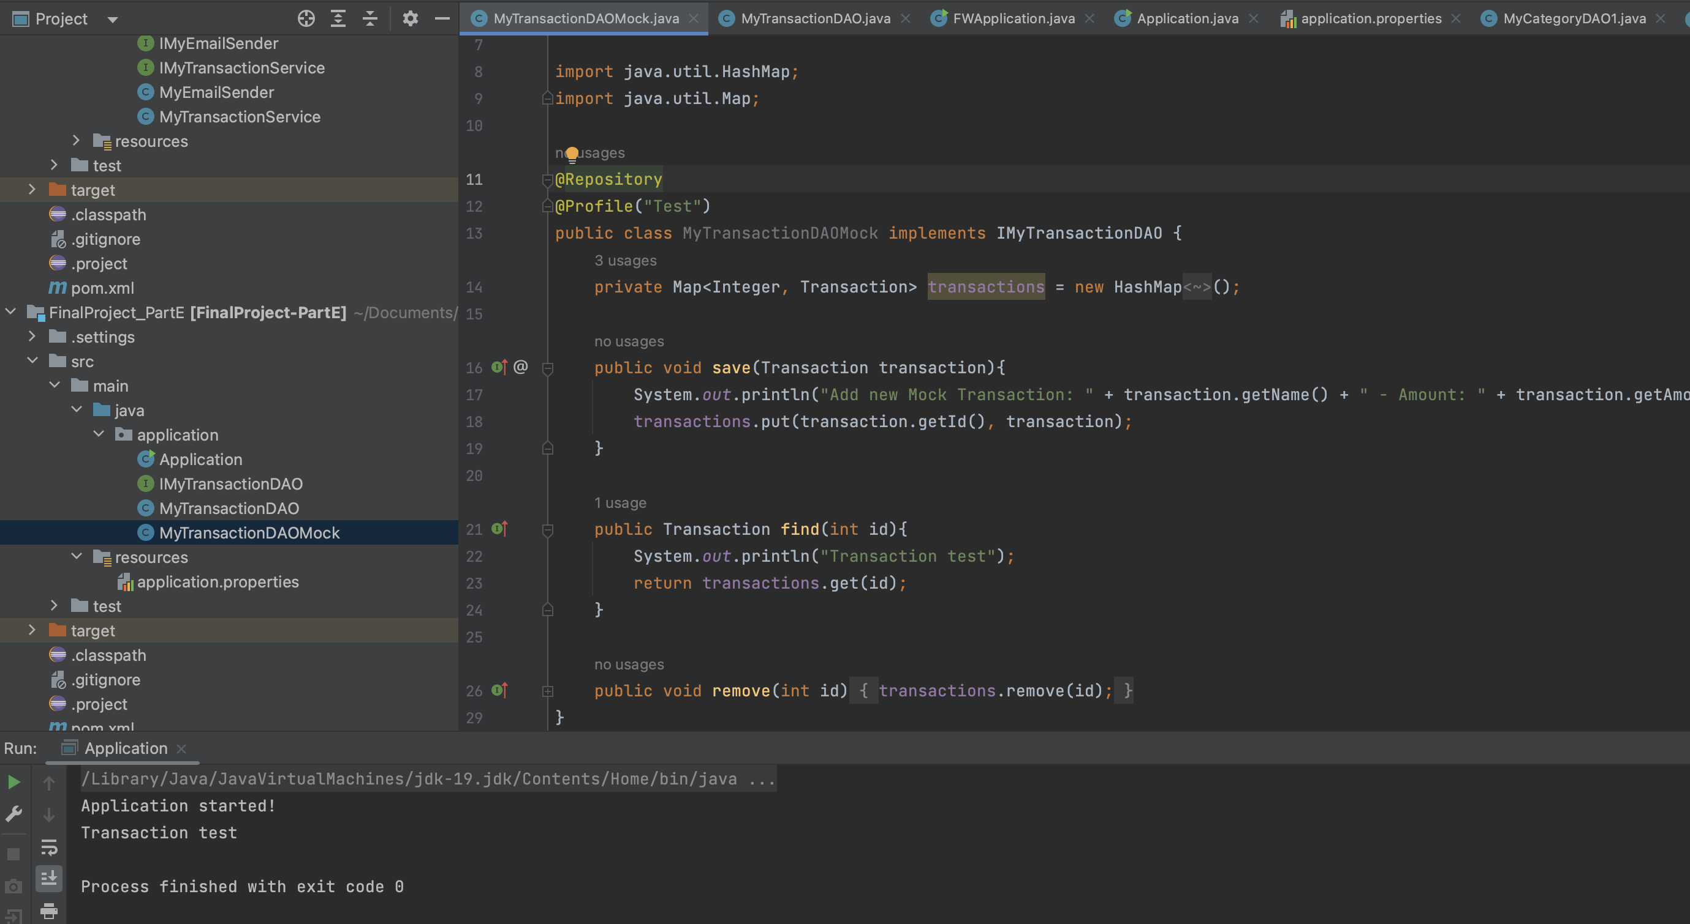

In application.properties, set spring.profiles.active=Test

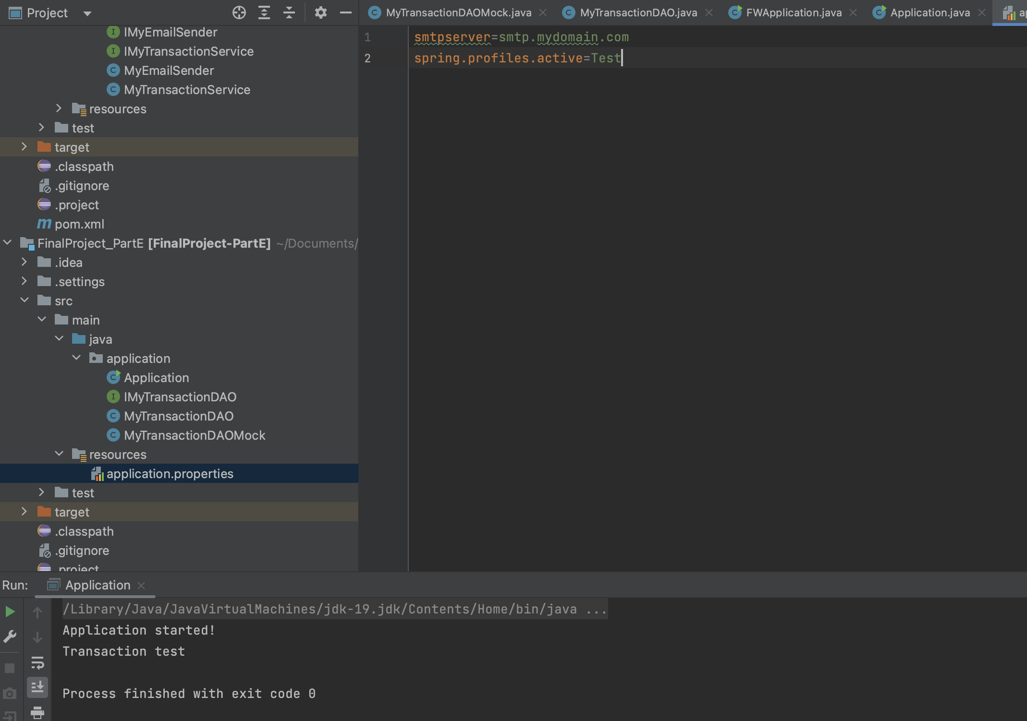

**PART F**

The framework supports scheduling using the @Schedule annotation

The application uses the framework successfully.

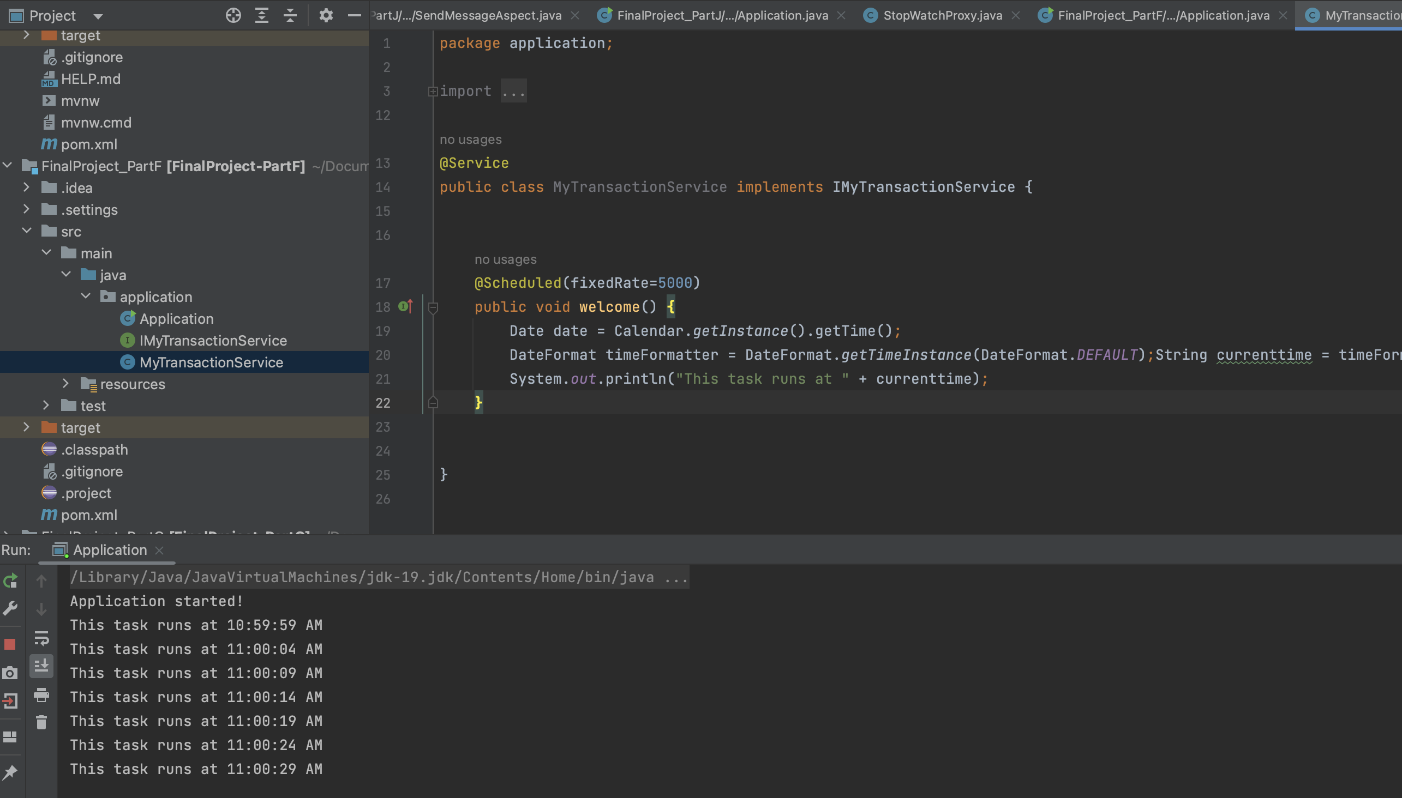

**PART G**

The framework supports scheduling using the @Schedule annotation with simple cron expression.

The application uses the framework successfully.

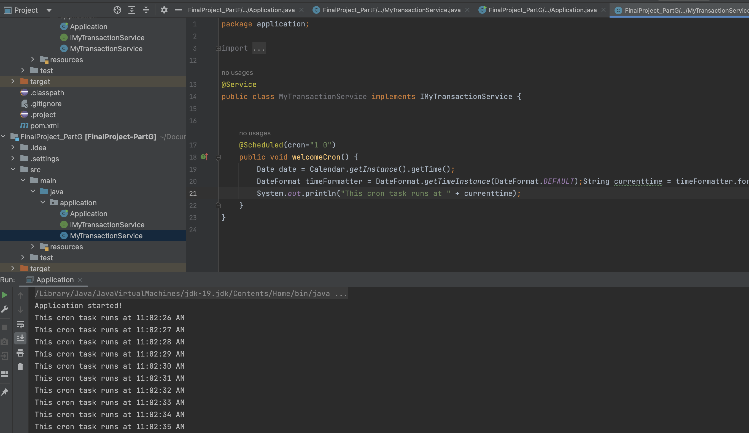

**PART H**

The framework supports events (publish-subscribe) like Spring Boot.

The application uses the framework successfully.

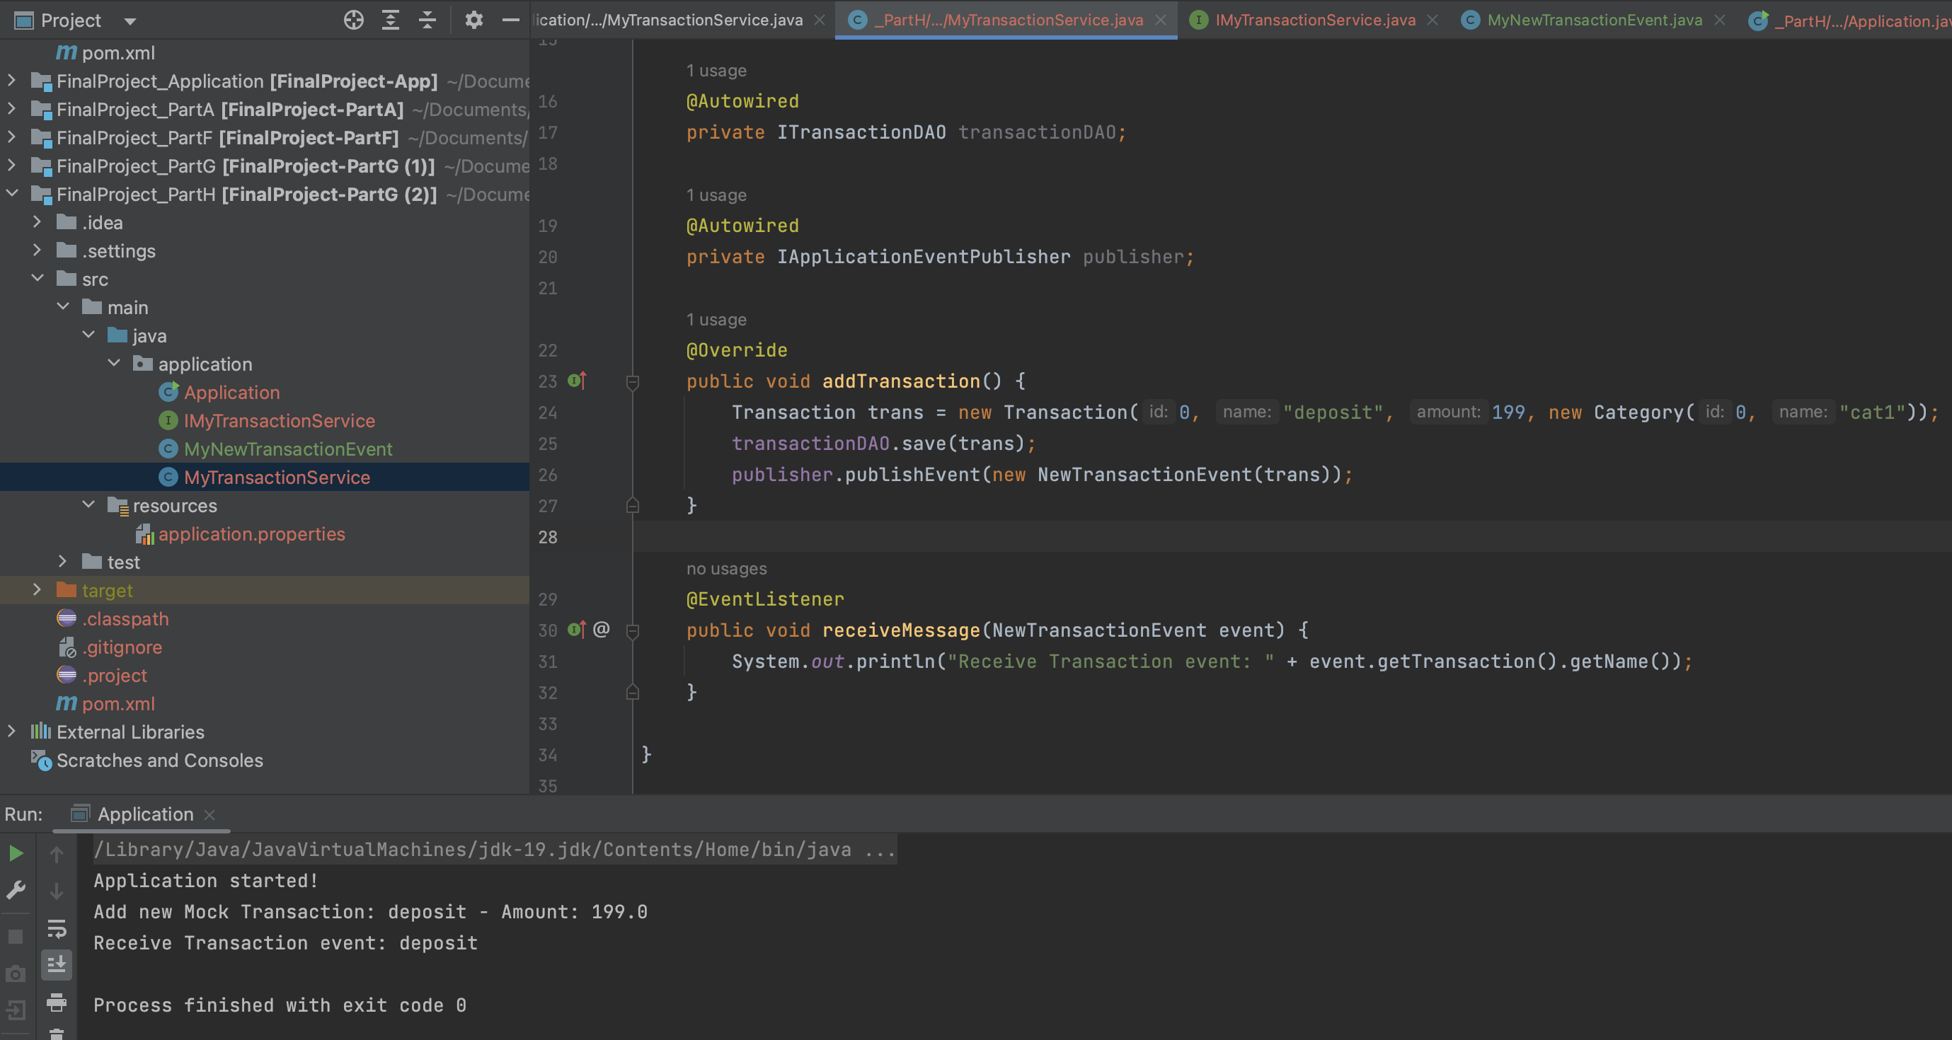

**PART I**

The framework supports asynchronous methods using the @Async annotation like Spring Boot.

The application uses the framework successfully.

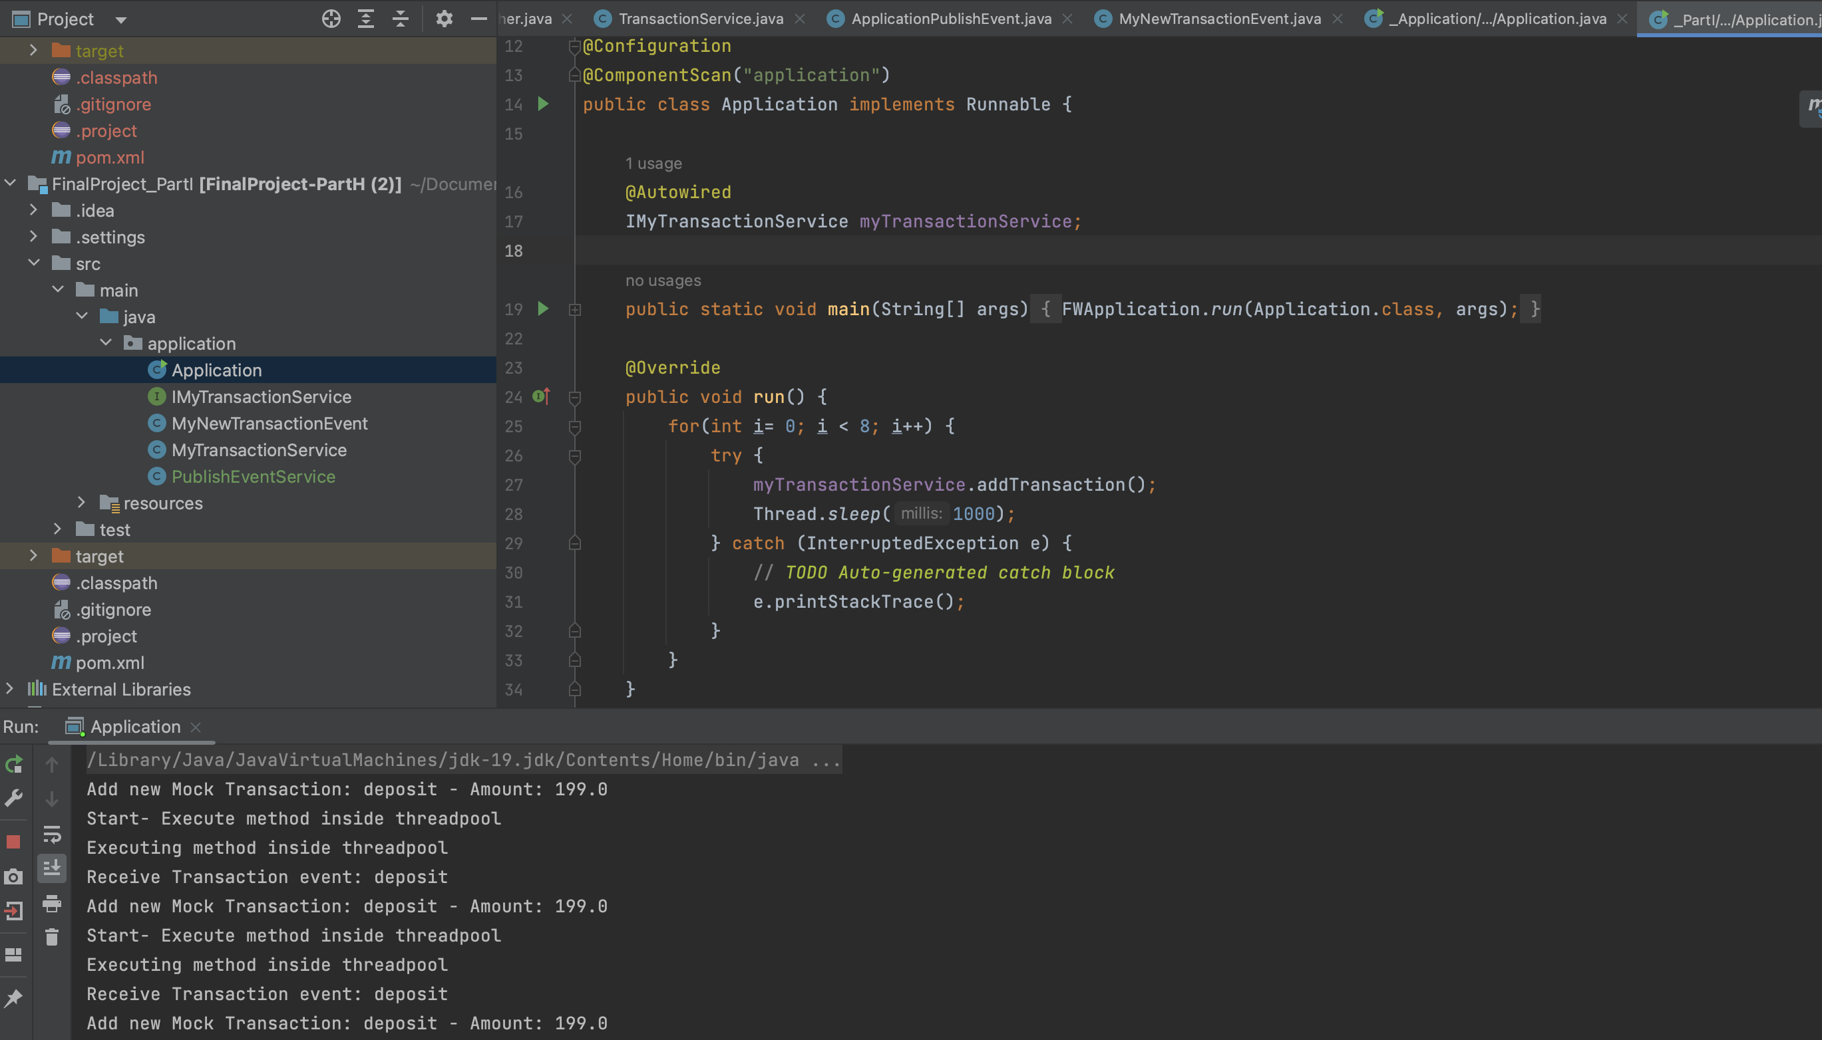

**PART J**

The framework supports simple AOP using the @Before and @After annotation like in Spring Boot.

The framework supports AOP using @Before:

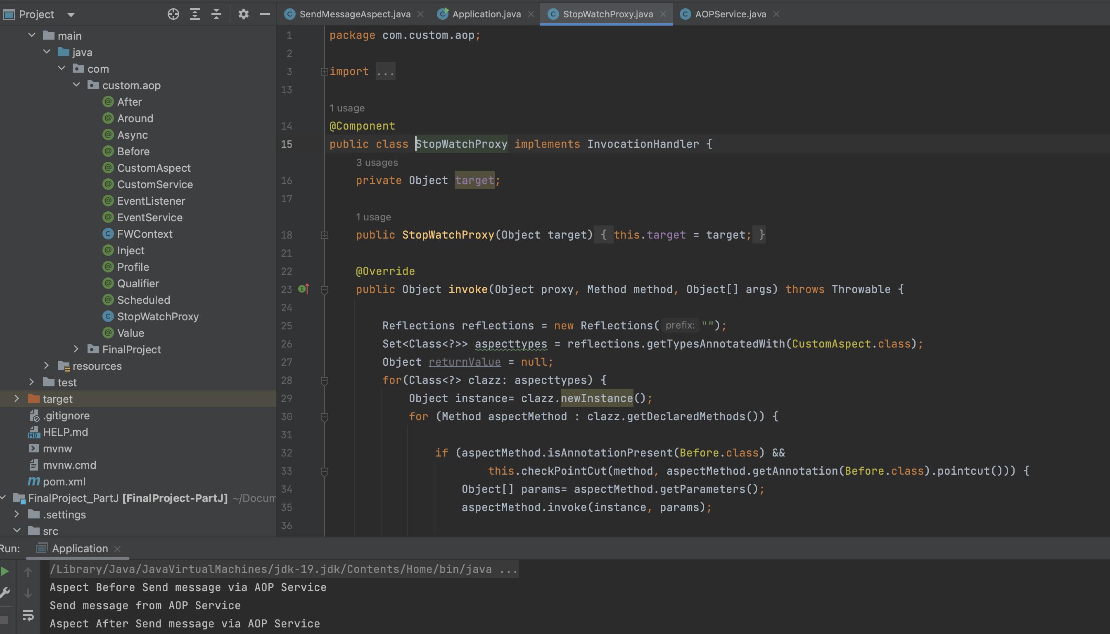

The framework supports AOP using @After:

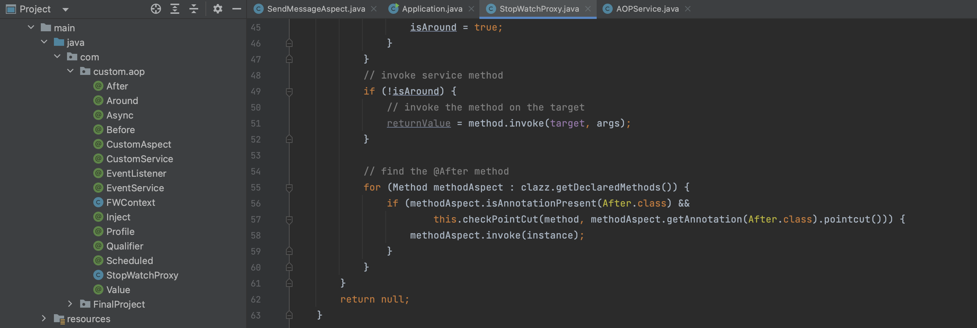

The application uses the framework successfully.

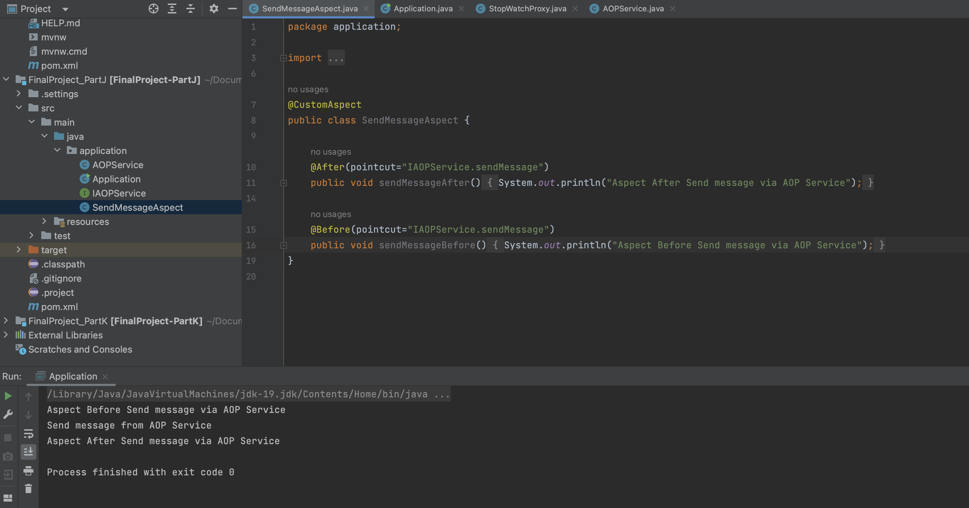

**PART K**

The framework supports simple AOP using the @Around annotation like in Spring Boot.

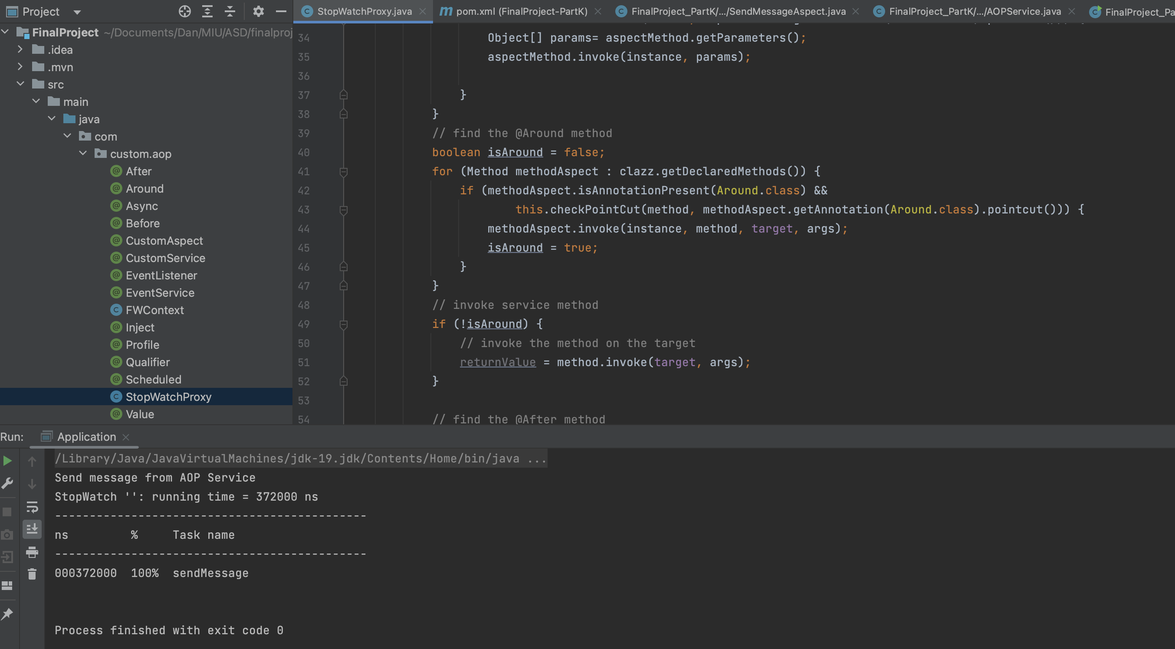

The application uses the framework successfully.

